**Uber Eats** is an [online food ordering](https://en.wikipedia.org/wiki/Online_food_ordering) and delivery platform launched by [Uber](https://en.wikipedia.org/wiki/Uber) in 2014. Meals are delivered by couriers using cars, scooters, bikes, or on foot. It is operational in over 6,000 cities across 45 countries as of 2021. The process of delivering food is still carried out by Uber drivers, who often only need a few minutes to finish a single service. In places where Uber Eats is offered, Uber will collaborate with multiple restaurants every day to serve meals to its customers.

**EER Diagram:**

**Tables:**

**Customers:**

**Developers:**

**Drivers:**

**Order_items:**

**Orders:**

**Payments:**

**Persons:**

**Regions:**

**Restaurants:**

**Uber_eats:**

**Joins operation:**

**Write a select statement that returns these columns:**

**Customer_name, prefered_restaurant_name, prefered_restaurant_region_name.**

**UNION operation:**

**Use customers and orders details using full outer join.**

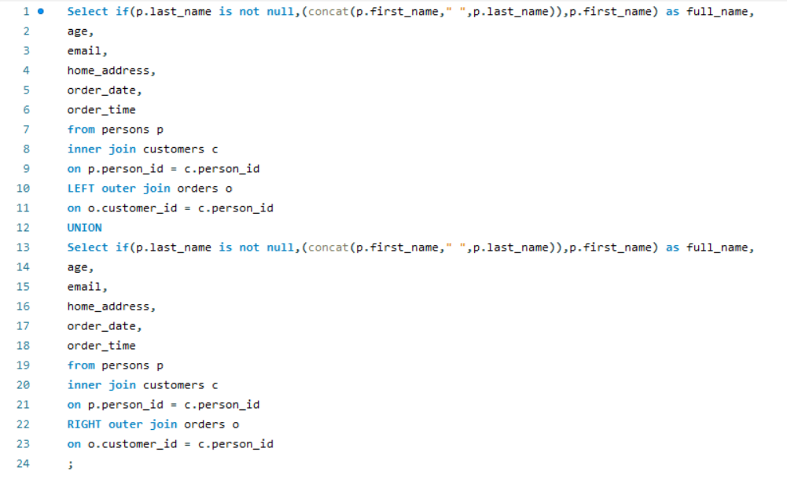

**Operation of SUM, MIN, MAX, COUNT, AVG**

**Tell the (total, average, minimum, and maximum) amount paid for each order in order_items table:**

**Operation of Functions:**

**Use the ROUND function to round the values from previous query to 3 decimal places.**

**Operation with subqueries:**

**Find details of drivers like: Name, age, license number, vehicle number, vehicle type and experience using Subqueries.**

